DeltaCad macro "CSV2Isometric.bas"
Submitted by registered DeltaCad Users Group member, “AlanCooper“.
This macro converts a 3D CSV (i.e. Comma Separated Values) file into an Isometric drawing (refer to Figure 1).
There is another macro (Isometric2CSV.bas) that can be used to export the drawing back to a 3D CSV file.
Figure 1 The macro option box
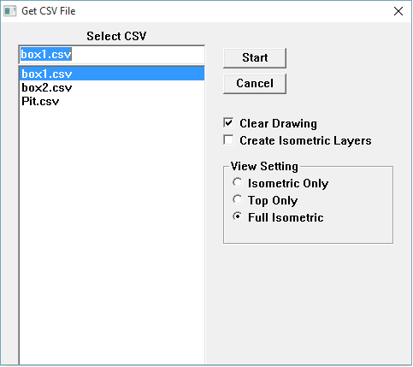

Figure 2 and Figure 3 present two examples.
Figure 2 Example Isometric 1 (the thing)
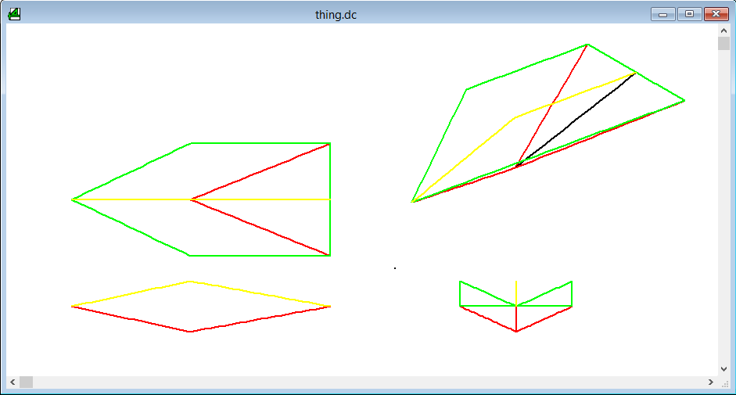

Figure 3 Example Isometric 2 (a survey pick up of an open pit)
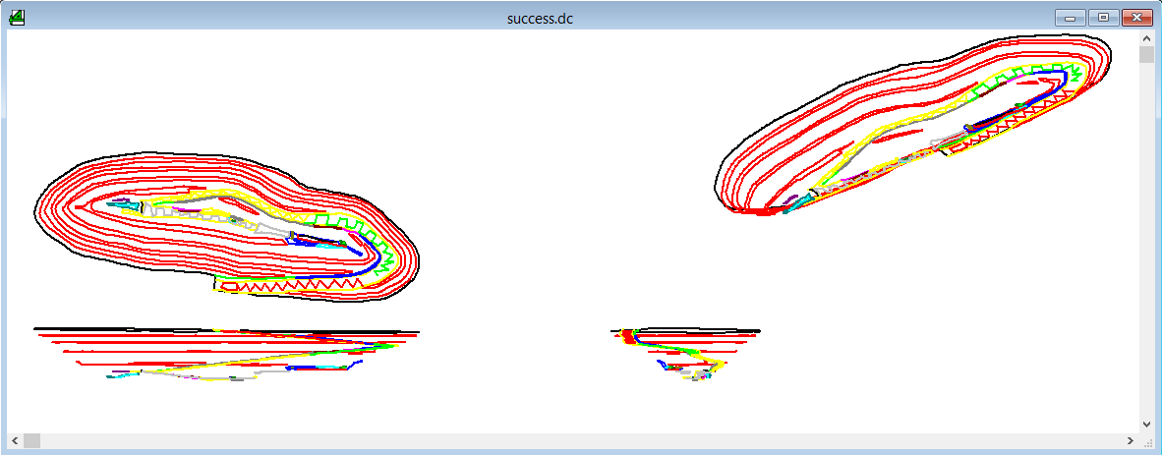

Macro Options
The options include:
- Clear the drawing before importing the data.
- Create the isometric layers (i.e. TOP, FRONT, SIDE and ISOMETRIC) if they don’t exist. These layers will be used for the imported data if they exist. If the layers don’t exist then all the data is imported into the current layer.
- Import an ISOMETRIC drawing only.
- Import a TOP drawing only (default).
- Import ISOMETRIC, TOP, FRONT and SIDE drawings.
NOTES:
- The macro is design to reside in the DeltaCad macro directory.
- The CSV file working directory is the same as Drawing 1. Best to open a single drawing and then save that drawing to the directory with the CSV file.
- Lines perpendicular to the page may exist for an isometric drawing. This is a problem for DeltaCad as they become invisible and practically impossible to select and edit. Therefore permanent points are used instead.
- The X and Y values from the CSV file are retained but Z values are relative. The macro presents the Z offset when done (refer to Figure 4).

Figure 4 The drawing Z offset
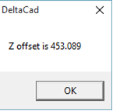

Figure 5 presents another isometric example.
Figure 5 Example Isometric 3 (not quite a box)
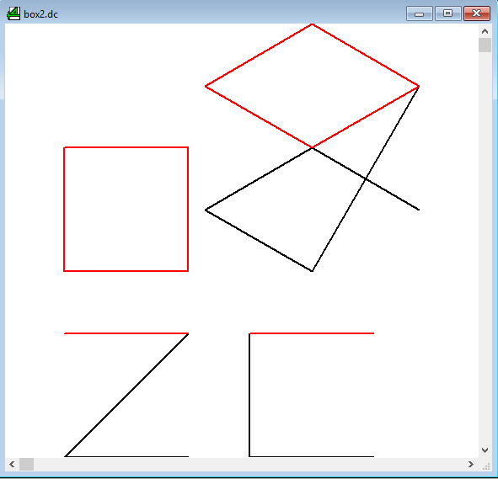

CSV File Format
The CSV file format is:
The first line is ignored but usually contains field names.
StrId: “String Id” – Any integer greater than 1 for data, 0 for a string/polyline/segment line break.
A line break is also indicated by a change in the string id.
The string id is used to map line colours (i.e. 1 = dcBLACK, 2=dcRED).
Only 16 colours so colours are reused (i.e. 17 = dcBLACK, 18=dcRED).
X X coordinate
Y Y coordinate
Z Z coordinate
Here is an example of a CVS file (a black and a red coloured square forming a box, refer to Figure 6):
StrId, X, Y, Z
1, 0, 0, 0
1, 100, 0, 0
0, 0, 0, 0
1, 0, 0, 0
1, 0, 100, 0
0, 0, 0, 0
1, 0, 100, 0
1, 100, 100, 0
0, 0, 0, 0
1, 100, 0, 0
1, 100, 100, 0
0, 0, 0, 0
2, 0, 0, 100
2, 100, 0, 100
0, 0, 0, 0
2, 0, 0, 100
2, 0, 100, 100
0, 0, 0, 0
2, 0, 100, 100
2, 100, 100, 100
0, 0, 0, 0
2, 100, 0, 100
2, 100, 100, 100
0, 0, 0, 0

Figure 6 Example Isometric 4 (a box)
