DeltaCad macro "Isometric2CSV.bas"
Submitted by registered DeltaCad Users Group member, “AlanCooper“.
This macro exports an Isometric drawing to a 3D CSV (i.e. Comma Separated Values) file.
There is another macro (CSV2Isometric.bas) that can be used to import a 3D CSV file.
The macro will first ask for a CSV file name (the directory will be the same as the first drawing that is open).
The macro will then ask for a Z offset. This value is the minimum Z value that will be exported.
The macro will then report how many segments were successfully exported.
Figure 1 presents an isometric example that can be export. You can use CSV2Isometric.bas to check the export.
Figure 1 Example Isometric 1 (not quite a box)
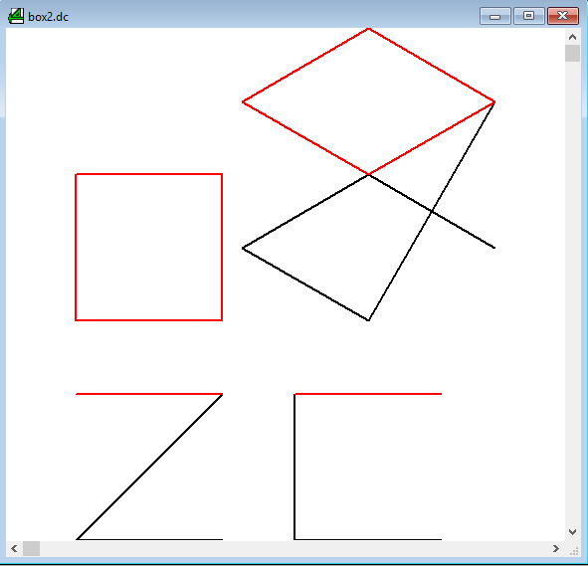
CSV File Format
The CSV file format is:
The first line is ignored but usually contains field names.
StrId: “String Id” – Any integer greater than 1 for data, 0 for a string/polyline/segment line break.
A line break is also indicated by a change in the string id.
The string id is used to map line colours (i.e. 1 = dcBLACK, 2=dcRED).
Only 16 colours so colours are reused (i.e. 17 = dcBLACK, 18=dcRED).
X X coordinate
Y Y coordinate
Z Z coordinate
Here is an example of a CVS file (a black and a red coloured square forming a box, refer to Figure 2):
StrId, X, Y, Z
1, 0, 0, 0
1, 100, 0, 0
0, 0, 0, 0
1, 0, 0, 0
1, 0, 100, 0
0, 0, 0, 0
1, 0, 100, 0
1, 100, 100, 0
0, 0, 0, 0
1, 100, 0, 0
1, 100, 100, 0
0, 0, 0, 0
2, 0, 0, 100
2, 100, 0, 100
0, 0, 0, 0
2, 0, 0, 100
2, 0, 100, 100
0, 0, 0, 0
2, 0, 100, 100
2, 100, 100, 100
0, 0, 0, 0
2, 100, 0, 100
2, 100, 100, 100
0, 0, 0, 0

Figure 2 Example Isometric 2 (a box)
